News Release
Santa Cruz County Clerk/Elections  701 Ocean St., Room 310  Santa Cruz, CA 95060  831-454-2060 / Fax: 831-454-2445  E-mail: gail.pellerin@santacruzcounty.us  Website: www.votescount.us & www.sccoclerk.us | 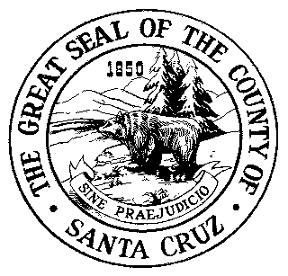
July 1, 2020

Contact: Gail L. Pellerin, County Clerk
831-454-2419 / 408-316-9745 (cell)

Vows at Valencia – free weddings at Valencia Park in Aptos on July 19
Pop the question and leave the rest to us! The Santa Cruz County Clerk and Santa Cruz County Parks have joined efforts to offer weddings at no cost on Sunday, July 19 at Valencia Hall, 2555 Valencia Rd., Aptos.
The decision to go ahead with plans for the free weddings was reached after the Center for Disease Control and Prevention released guidelines for weddings and other gatherings on June 12.
Couples can book their “Vows at Valencia” free wedding ceremony online at www.sccoclerk.us, or call the Santa Cruz County Clerk at 831-454-2060.
Ceremonies will occur every 30 minutes from 1pm until 6pm, on Sunday, July 19. A limited number of spots are available.
“Vows at Valencia” will take place outdoors, the number of guests is limited to 15, and guests are required to wear masks covering their nose and mouth.
The free wedding event is part of July's “Parks Make Life Better” month in Santa Cruz County. Due to COVID-19, many events have had to be canceled, but parks remain open for people to enjoy the outdoors.
“During this time of uncertainty, we are so happy to be able to offer couples a chance to exchange vows in such a gorgeous setting,” County Clerk Gail Pellerin said. “Love truly can conquer all!”
Pellerin stressed that the deputy commissioners of civil marriage and parks staff will follow public health guidelines regarding wearing a mask, frequent hand washing, disinfecting surfaces, and maintaining physical distances. Anyone displaying signs of sickness will not be allowed to be at the event.
There is no cost for the wedding ceremony; however, couples must purchase a marriage license prior to July 19. Couples can buy their marriage license from any County Clerk’s office in the state. County Clerk offices are only open on weekdays. Marriage licenses are valid immediately and good for 90 days.
Marriage licenses in Santa Cruz County cost $90 and are issued by the Santa Cruz County Clerk located at 701 Ocean Street, Room 310, in Santa Cruz. To obtain a marriage license, each party to the marriage must appear in person with valid identification, complete a form supplying personal information, and take an oath. Couples must book an appointment online at www.sccoclerk.us to get a marriage license.
Couples must have at least one witness present for a public marriage. Confidential marriages do not need a witness.
For more information, please call 831-454-2060 or visit the County Clerk’s website at www.sccoclerk.us.
-end-

